Vaibhav Garg

vaibhav.garg@genus.in

Abstract

A short guide to navigating around and Managing your projects using EinFrame

Einframe

Getting Started and Project Management

# Contents

Contents 1

Purpose 2

General Setup and Getting Started 3

Logging In 3

Password Reset 4

Navigating Around 5

Icons and Symbols 6

Action Toolbar 7

Change User Account Details 8

Inline Help 9

Printing Reports 9

Projects 11

Purpose 11

Capture 11

Capture the Basic Details 12

Team and Talent Planning 13

Asset Planning 17

Knowledge Planning 22

Technology Requirements 26

Project Risk Management 27

Project Tasks 29

Publishing the project 30

Project Execution- Gate Reviews 31

Project Execution- Timesheet entry 33

Project Execution- Project Task approval 37

Reports 38

Projects Report 38

Project Gates Report 39

Project Tasks Report 39

EVMS Chart Report 39

Bull’s Eye Chart Report 40

Timesheet Download 40

Resource Loading 41

# Purpose

Our Enterprise Innovation Framework has just one goal on its mind – Inspire our customers to *Think Next and capture market share*. Best practices in innovation management from decades of experience have been packaged in this user-friendly application, which can be further customized to meet the needs of any product development organization. If you are committed, this application will help you build a culture of innovation.

EinFrame engages everyone across the enterprise, like an ERP or a PLM system. What makes it unique is its focus on the future as well as the present state of product development at a level above ERP/PLM system. The core information architecture aligns product specifications, project progress, talent, and knowledge with company strategy and competitive landscape. All of the modules come together to facilitate a closed loop of Metrics-Strategy-Execution-Metrics building a culture of robust innovation and productivity improvement.

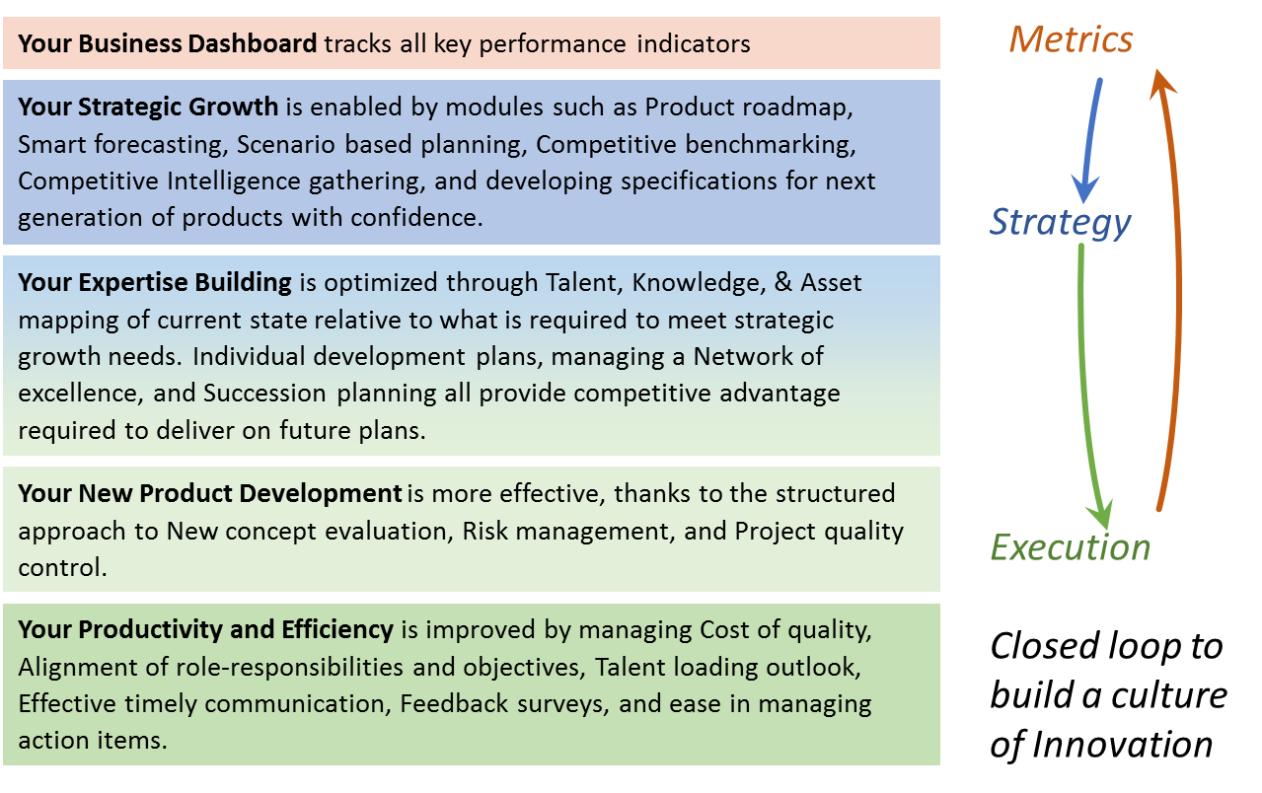

# General Setup and Getting Started

## Logging In

Open the Web Application and Enter your Login Credentials (Figure 1: Login). The Login credentials are protected using state-of-the-art AES256 hashing at the backend so that no-one, including the developers, can access those.

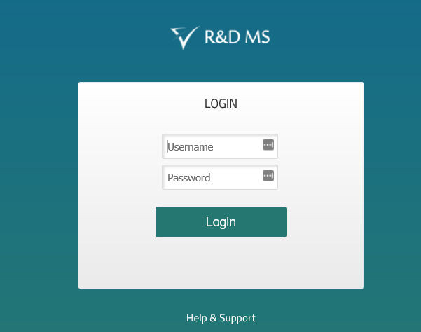

Figure : Login

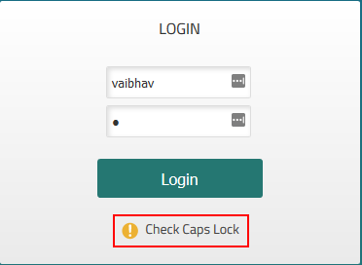

Figure : Make Sure the CAPS LOCK is not on.

If the Credentials are correct, the user lands on the page shown in Figure 3: End User License Agreement Page on the first login and the page similar to the one shown in Figure 4: Application landing Page on subsequent logins.

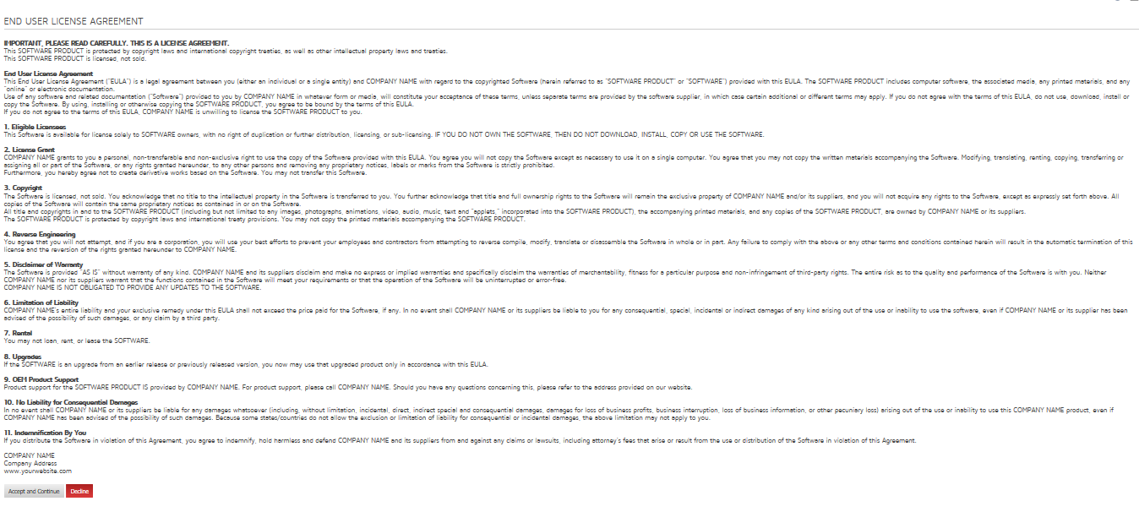

Figure : End User License Agreement Page

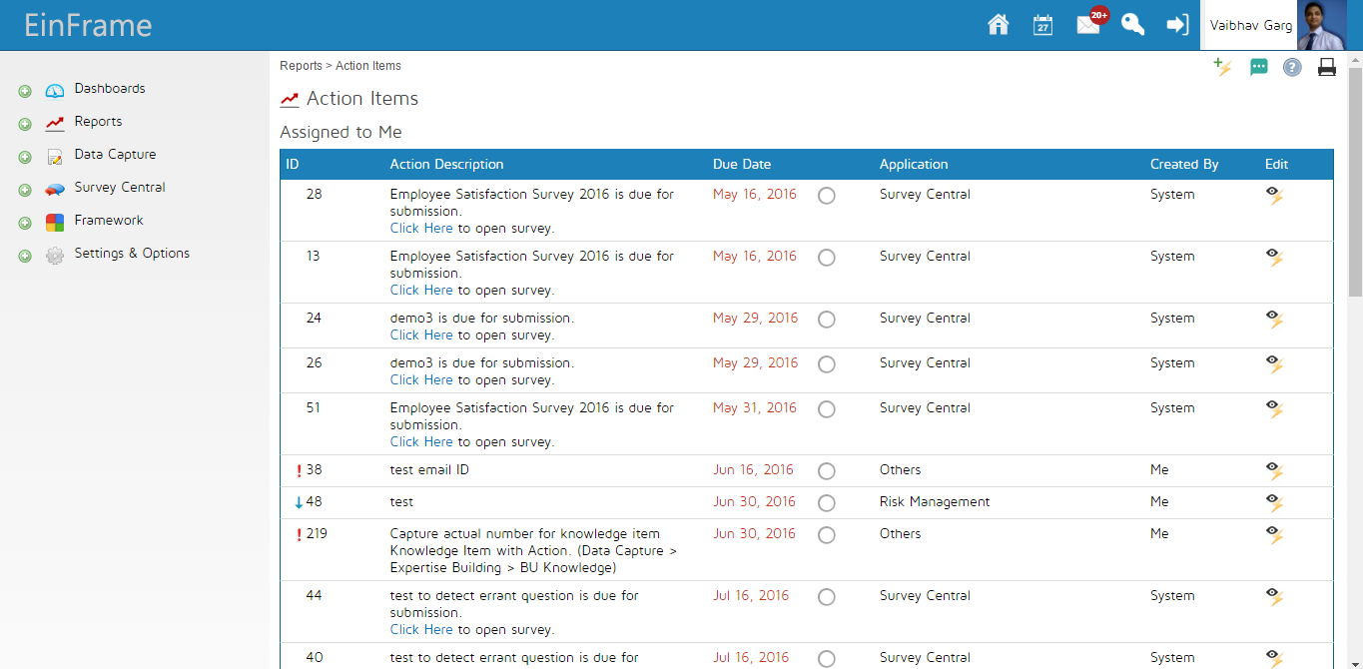

Figure : Application landing Page

If you have forgotten your password, or have trouble logging in, you can contact your admin. The admin can assign a new password to you. See section “Password Reset”

## Password Reset

Only an administrator can reset the passwords of users. To change the password of the user, go to Framework>>Internal/Business >> Employees.

Click on the  icon next to the employees name. Click on the  button towards the top of the page. The application asks for the new password twice as shown in Figure 5: Forgot Password?. Enter the new password and communicate the same to the employee.

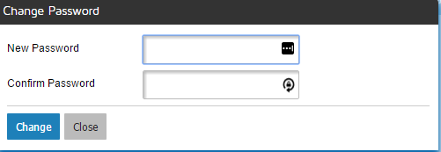

Figure : Forgot Password?

## Navigating Around

Navigation within the application is intuitive and uses the standard modern web paradigms. On the top of the screen, you would notice the “TOP NAVIGATION BAR”. (Figure 6: Top Navigation Bar) The icons enable quick access to useful settings and details, explained in the section Icons and Symbols. This also shows the Action Toolbar.



Figure : Top Navigation Bar

On the left side of the screen, you would see the “Left Navigation Bar” (Figure 7: Left Navigation Bar). This contains the menu structure to access the functionality of the web application and would be the starting point for most navigation. The Menu is laid out in the form of cascading menus and submenus that cascade on clicking the small  icon right in front of the same.

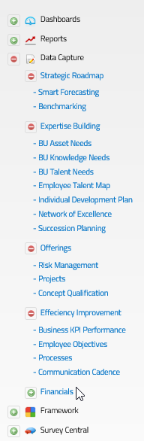

Figure : Left Navigation Bar

### Icons and Symbols

The following Icons are used in the application in various places.

| ICON | LOCATION | Function |
| --- | --- | --- |
| Home | Figure 6: Top Navigation Bar | Brings the application back to the Home page  The user can also click the Application Logo on the top left to bring the application back to the home page. |
| Communication Cadence | Figure 6: Top Navigation Bar | Communication Cadence Report |
| Messages | Figure 6: Top Navigation Bar | Takes you to the message center |
| User Account | Figure 6: Top Navigation Bar | Opens Figure 8: Change and Fill Login Details |
| Logout | Figure 6: Top Navigation Bar | Logs the user out of the application |
| Inline Help | Multiple Locations | Refer Inline Help. |
| http://genus.aufice.com/images/icoactionadd.pngAdd Action Item | Multiple Locations | Adds a New action Item. |
| http://genus.aufice.com/images/icoactionview.pngView Action Item | Multiple Locations | View Linked action Items. |
| http://genus.aufice.com/images/icoedit.pngEdit | Multiple Locations | Context Sensitive |
| http://genus.aufice.com/images/icodelete.pngDelete | Multiple Locations | Context Sensitive |
| http://genus.aufice.com/images/icoadd.pngExpand/Add | Multiple Locations | Context Sensitive |

### Action Toolbar

On Each Page of the application, the user has an Action toolbar available on the top right of the page, just below the navigation bar. ()

The Action toolbar has the following functionality (From Left to right)

|  |  |
| --- | --- |
| Icon | Function |
|  | Add an action item |
|  | Application Feedback.  This brings up a feedback window |
|  | Print the form |

### Change User Account Details

Any Logged in user can change their passwords and upload their photograph using Account Icon  in their top Navigation Bar. This will take them to the screen shown in Figure 8: Change and Fill Login Details.

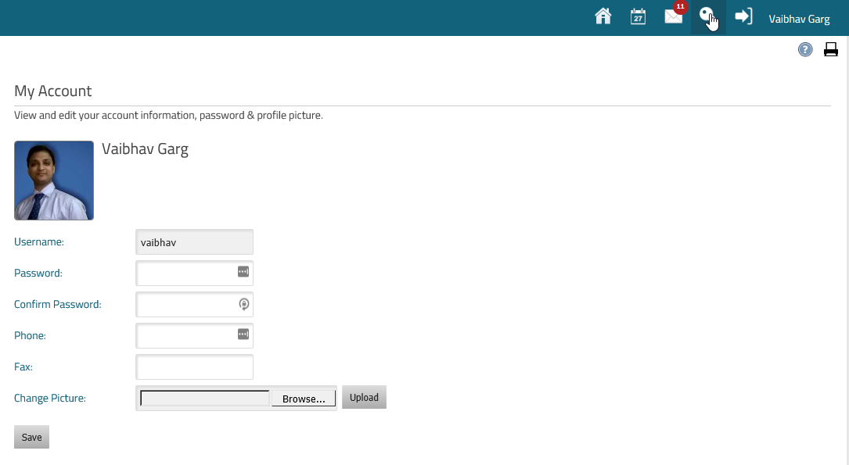

Figure : Change and Fill Login Details

Additionally, the user gets to see all system admins on this page.

## Inline Help

The Application supports an intuitive way to capture and view inline help and tips. Where ever you see an icon in the application, an inline tip is available in the application to ease application use.

If you are an administrator, the inline tip looks like -Figure 9: Help- Admin View and Update. The tip opens in an editable format and you can add/delete and edit the content. Once you click save, the same is updated in the application for all users, including other Administrators.

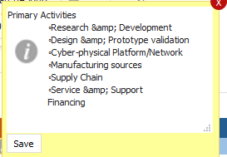

Figure : Help- Admin View and Update

If you are not an Administrator of the application, the tip appears like in Figure 10: Help: Non-Admin View. This is a tip that one of the application administrators has set up for you.

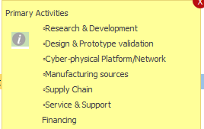

Figure : Help: Non-Admin View

## Printing Reports

The user can Print the page they are on using the  icon on the top right of the page. Most browsers, however, do not print the background of the page by default, and result in the print looking very different from the page on screen.

To enable printing backgrounds, look for the option in your favourite browsers page setup/print options. These look similar to Figure 11: Print backgrounds in IE in Internet Explorer and Figure 12: Print Background in FireFox.

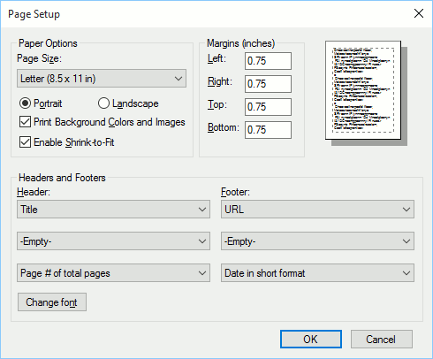

Figure : Print backgrounds in IE

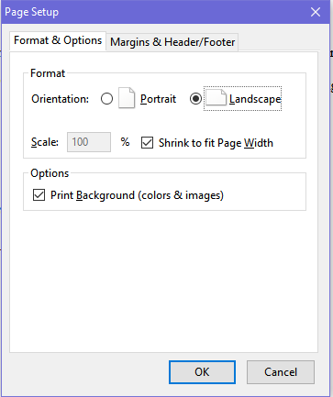

Figure : Print Background in FireFox

# Projects

## Purpose

The purpose of the project Module is to

1. Provide the roadmap direction to the Enterprise by successive detailing of all projected endeavours in the form of projects and project needs
2. Provide a basic project management functionality to plan for people, information and assets to successfully execute a project; and track the execution through critical milestones or Project gates.

## Capture

Navigation:

Data Capture>>Innovative Development >> Projects

On navigating to this page, the user sees the screen as shown in Figure 13: List of All Projects. This list shows all the projects that have been defined in the system.

The list shows-- at a glance – the name of the project, the business unit it belongs to, the name of the project manager, the type of the project – whether “Product” or “Technology”— , the project timelines, and the icons to edit.

The  icon on the left turns green for published projects and is gray for unpublished projects. The  icon appears only for published projects and is the entry point for Project Execution- Gate Reviews.

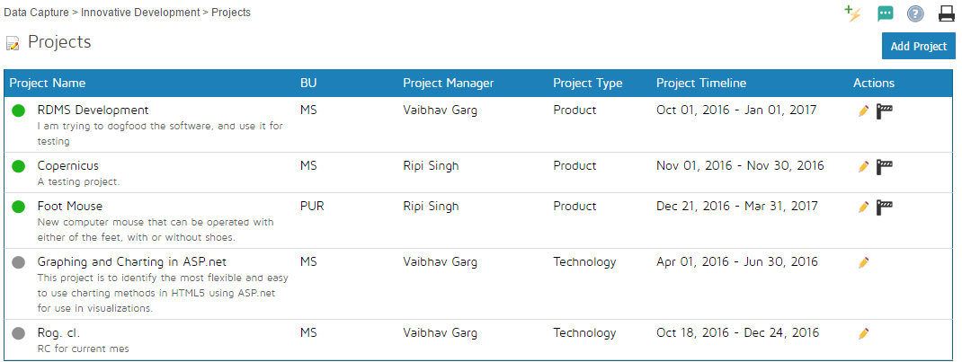

Figure : List of All Projects

### Capture the Basic Details

On clicking the  button on the screen shown in Figure 13: List of All Projects, the user is taken to the page shown in Figure 14: Capture the Basic Project Details.

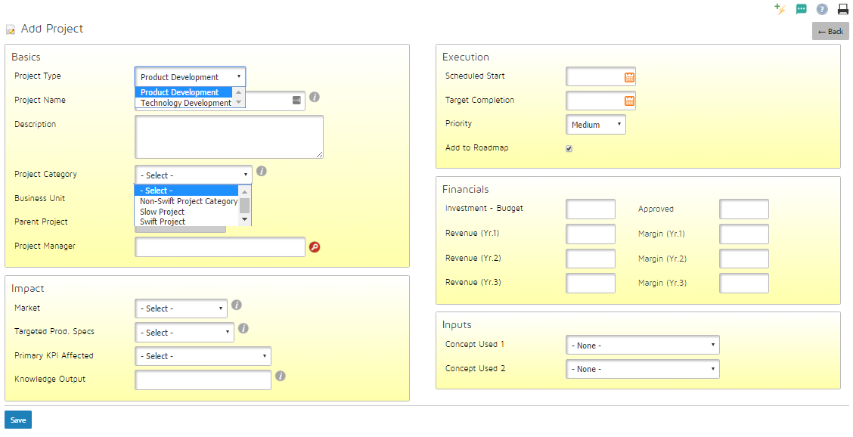

Figure : Capture the Basic Project Details

The form in Figure 14: Capture the Basic Project Details is designed to capture the following details.

1. The project Type: a choice between **Technology Development Project** and **Product Development Project**. Note that the chice made here CANNOT be changed at a later date once this is saved.
2. Project Name: This is free text to supply the name of the project.
3. Project Description: Describe the project in a few words here.
4. Project Category
5. Business Unit: The name o f the business unit that owns the project. You may also select enterprise if this is a cross BU project.
6. Parent Project: This is applicable only for Technology Development Projects. The technology Development project may be leading upto the development of a product, in which case the Product development project is a parent to the Technology Development Project. More details are in Technology Requirements section.
7. Project Manager: Click on the  icon and search for the name of the project manager.
8. Scheduled Start: Clicking on the field brings up a calendar from which you can select the schedued start date of the project.
9. Target completion: Clicking on the field brings up a calendar from which you can select the Target completion date of the project.
10. Priority: Select the project priority from High, Medium and Low
11. Add to Roadmap: This selects whether the project is shown as a part of the roadmap.
12. Market: This is a choice based on the markets added in the Framework. The primary market that the project is intended to address should be selected here.
13. Targetted Product Specs : The product specificications that the project will target should be entered here. This is a dropdown from the product specifications defined in the application.
14. Primary KPI Affected: Specify the primary KPI in the Domain which the project addresses.
15. Knowledge Output: Every Technology Development Project results in a documented piece of knowledge. This piece of knowledge needs to be added to the framework so that the required and actual levels can be tracked using the Knowledge Maps and Gaps functionality. In this field, specify the name of the Kowledge item that will be added to the Knowledge framework under the technology classification. **Product Development projects may leave this blank**.
16. Investment- Budget: Specify the investment budgeted for this project.
17. Investment- approved: Specify the investment approved for this project.
18. Revenue (yr 1 to3): Forcast the additional revenue that this project will bring 1, 2 and 3 years post completion.
19. Margin (Yr 1 to 3): Forcast the additional profits that this project will bring 1, 2 and 3 years post completion.
20. Concepts Used: Specify (up to 2) concepts that are leveraged for this project,. Only the concepts that are “Reviewed and accepted” and “Used in a project” are available for selection. The status of the concept is automatically changed to “Used in a project” on selecting and saving in a project.

On clicking the  button on the bottom left, the screen as shown in Figure 15: Project Page after Saving Basic Details is shown. The key change is that multiple additional buttons are now available for detailed planning of the project.

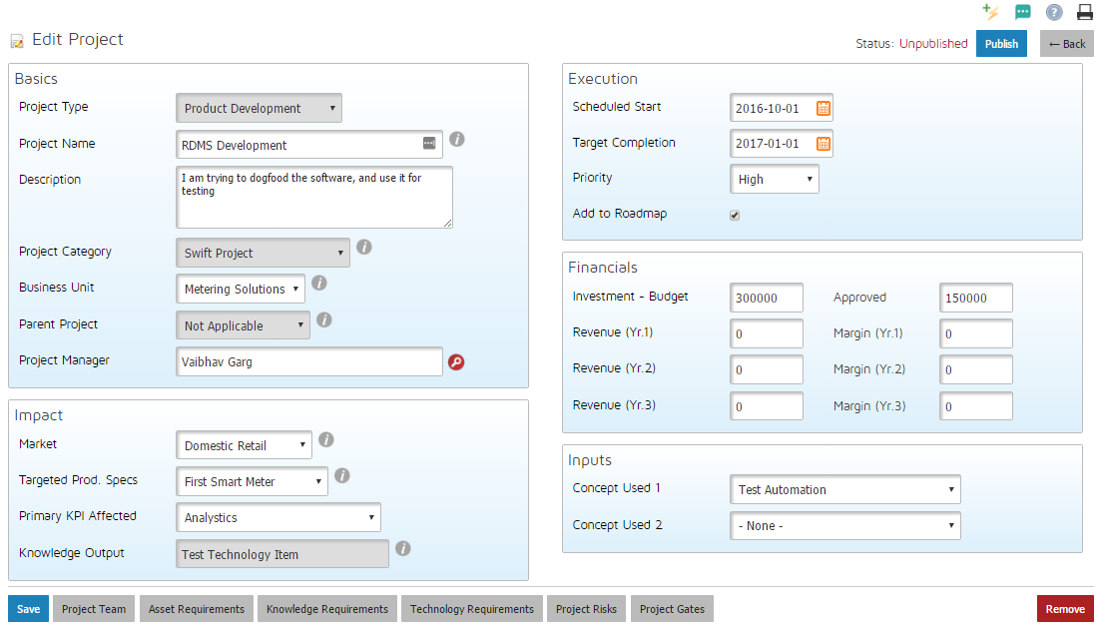

Figure : Project Page after Saving Basic Details

Please note that the “Technology Requirements” button ( ) is not available for Technology Development Projects.

### Team and Talent Planning

The first button from the left, , will take the user to the screen as shown in Figure 16: Project Team

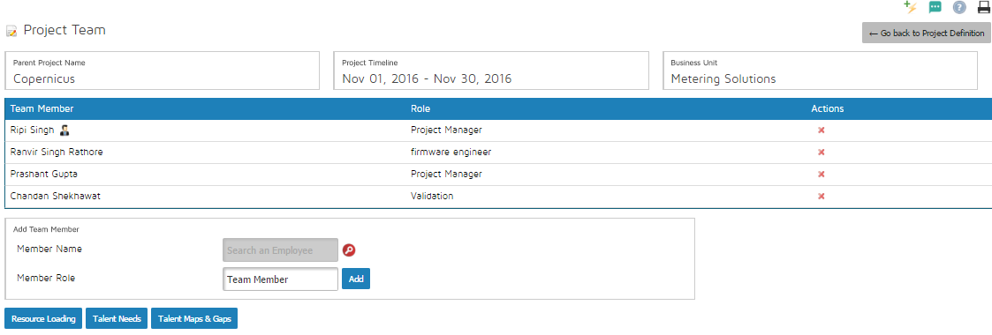

Figure : Project Team

On this screen, you can select your team members and specify their roles in the project.

To add a new team member, click on the  icon as shown in Figure 16: Project Team, which shall take you to the screen as shown in Figure 17: Add Team Member. Here you can search for the team member by name.

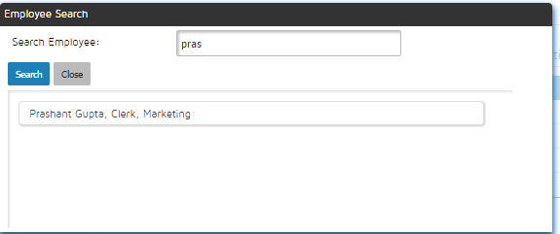

Figure : Add Team Member

After selecting the team member, specify the role of the member using the “Member Role” Field in the screen shown in Figure 16: Project Team and click .

After adding the team members, click on  . This will allow you to specify what and how many skills/talent are needed for successful execution of the project, at each skill level. Once this is done, click . This is illustrated in Figure 18: Specifying the Project Talent Needs.

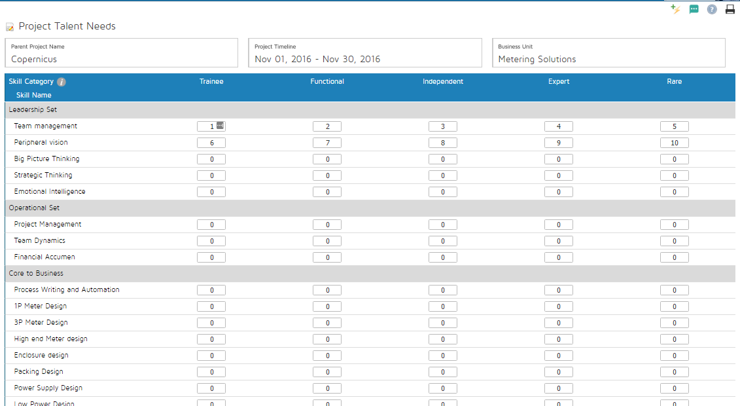

Figure : Specifying the Project Talent Needs

The talent map of each of these team members is already updated in the system. The project manager has now updated the project talent needs using the workflow described above using Figure 18: Specifying the Project Talent Needs.

On clicking the  button, the application will report the Talent gaps with respect to the talent inputs of the team that has been selected and the talent needs of the project. This is as shown in Figure 19: Comparing the selected Teams Talent with the Project Talent Needs-Tabular. The Red background Gaps indicate shortfalls and the Green background Gaps indicate excess.

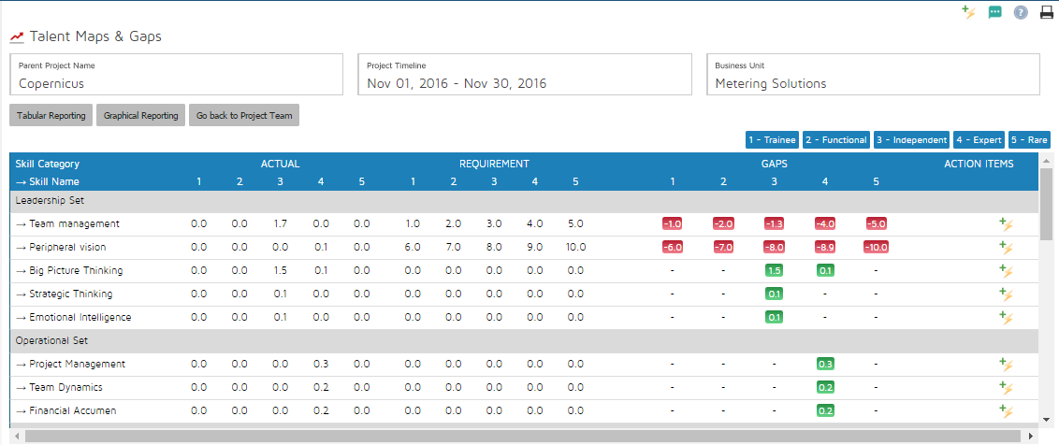

Figure : Comparing the selected Teams Talent with the Project Talent Needs-Tabular

Another visualisation of the same information can also be visualised in a graphical format by clicking  button which takes you to the screen as shown in Figure 20: Comparing the selected Teams Talent with the Project Talent Needs-Graphical. The green filled circles indicate excess while the red bordered blank circles indicate shortfalls.

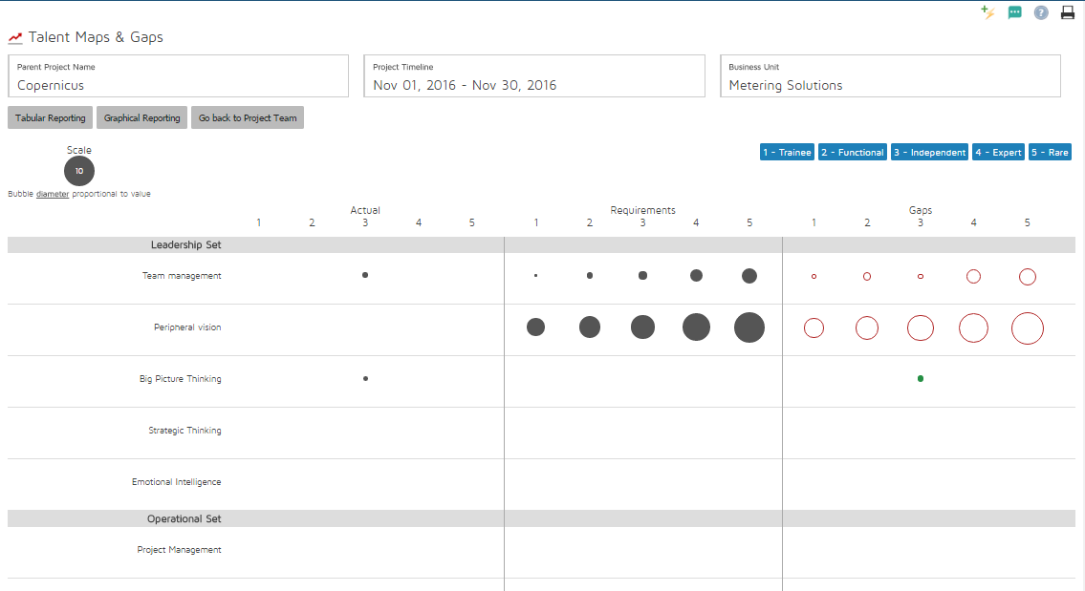

Figure : Comparing the selected Teams Talent with the Project Talent Needs-Graphical

#### Resource Loading

Another critical aspect, in addition to the team talent, is the team availability. Clicking the  button on the screen shown in Figure 16: Project Team will take you to the screen as shown in Figure 21: View the Resource Loading and Adding the Project Loading for each Resource. **PLEASE NOTE THAT YOU DO NOT NEED TO ENTER DATA MANUALLY HERE IF THE PROJECT TASKS MODULE IS USED.**

On this screen, the project manager can enter the percentage loading on a weekly basis for the project team members. The numbers on the right of each text box are the aggregate of loading from all other projects in the week under consideration. These are colour coded to indicate overallocation.

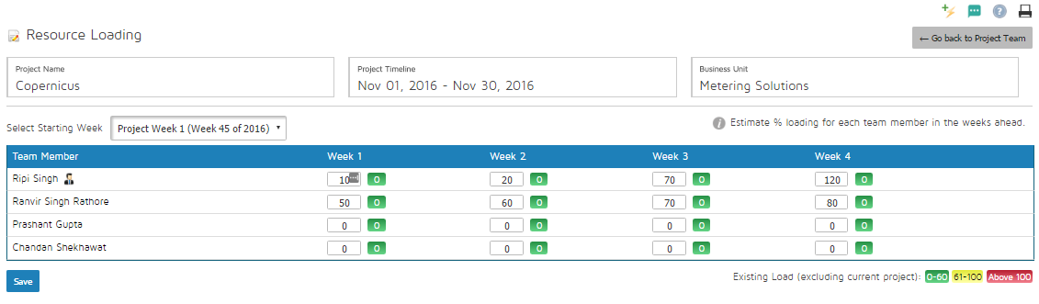

Figure : View the Resource Loading and Adding the Project Loading for each Resource

A special aspect to note here is that if the project starts or ends in the middle of the week, the project manager is expected to discount the percentage loading with respect to the number of days within the project life cycle.

As an example, if a resource is needed from the start of the project for 50% of the time, and the project starts from Wednesday, the project manager is expected to enter 5/7 (Wednesday through Sunday) of 50%, that is, 35%.

### Asset Planning

To execute a project successfully, the project manager has to plan for the asset requirements. On clicking the  , the user is taken to the screen as shown in Figure 22: List of all Assets Required by the Project. The aggregated assets from all projects, based on the time when they are being executed, are used as BU Asset needs to derive the BU and Enterprise Level Asset Maps and Gaps.

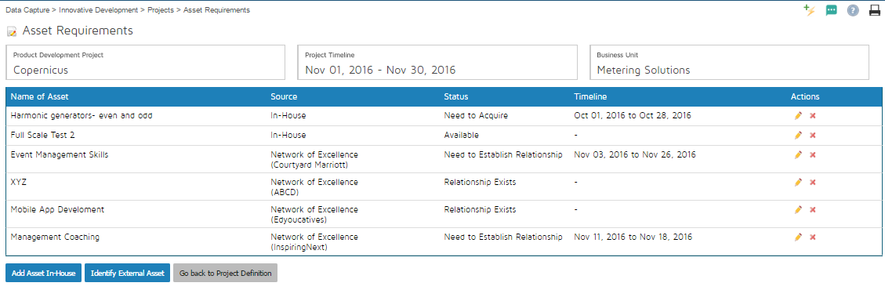

Figure : List of all Assets Required by the Project

The assets can either be in-house assets, that are or will be a part of the asset framework, or can be external assets that are supposed to be sourced from the Enterprise’s Network of Excellence

#### In House Asset

An in-house asset is the one that is either already a part of the Asset framework, or is planned to be a part of the same.

On clicking the  button as shown in Figure 22: List of all Assets Required by the Project, the user is taken to the screen as shown in Figure 23: Add In-house assets that already exist in the Application Asset Framework. The user can then either select the asset from the Framework, or choose to add to the framework itself.

If the user chooses to select from the framework, the screen similar to Figure 23: Add In-house assets that already exist in the Application Asset Framework is seen where the user selects the name of the asset from the dropdown and selects the level and the quantity of the assets. The quantity of the Asset under consideration at the selected level is shown to the user on the right side of the screen, as shown in Figure 24: Current Quantity of the selected Asset Item.

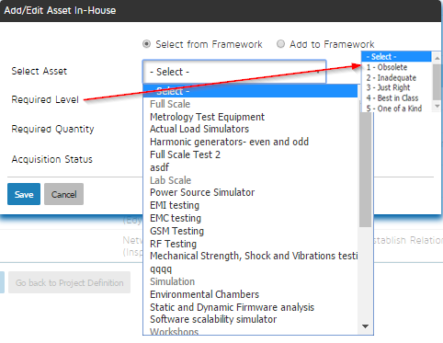

Figure : Add In-house assets that already exist in the Application Asset Framework

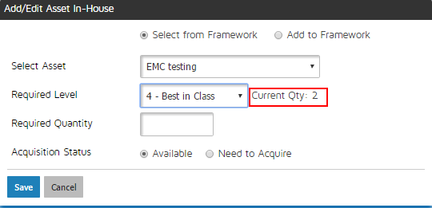

Figure : Current Quantity of the selected Asset Item

If the user chooses to add to the framework, a screen shown in Figure 25: Add a new asset to the project AND to the Application Asset Framework is seen. The user enters the name of the asset, its category, level and quantity and the same gets added to the Framework.

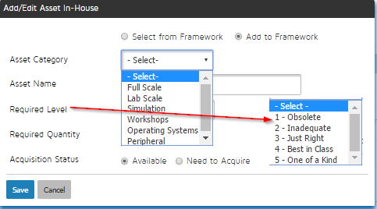

Figure : Add a new asset to the project AND to the Application Asset Framework

In both the above cases, the asset may already be available or it may need to be acquired. If the asset is available, the user can just save and proceed further.

If the asset needs to be acquired, as shown in Figure 26: Plan for asset acquisition if not available, the user needs to enter the start and end dates of acquisition.

The end date of acquisition needs to be on or before the end date of the project. The start date must be before the end date.

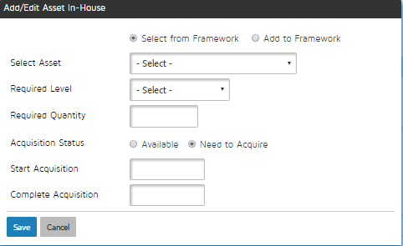

Figure : Plan for asset acquisition if not available

#### External Asset Sourced from NOE

An external asset may be planned for when the asset required is neither a part of the framework, nor is planned to be in the foreseeable future. This may include, but not limited to, expensive tools and equipment that are for a one-off use.

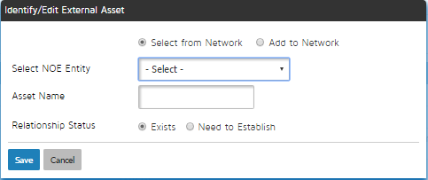

Figure : Identify an existing connection for Project Asset Need

To add an external Asset, click the  on the screen shown in Figure 22: List of all Assets Required by the Project. This opens up the screen as shown in Figure 27: Identify an existing connection for Project Asset Need.

If the NOE entity exists, you can select from the dropdown and enter the Asset name that you would like to use from the NOE. This is as shown in Figure 28: Add a new connection for Project Asset Need. An action item is creade to fill out the details.

If the NOE entity needs to be added, The user may enter the network type, the NOE entity name, The relationship strength and the Asset name. This adds the NOE basic details to the Network of excellence Database.

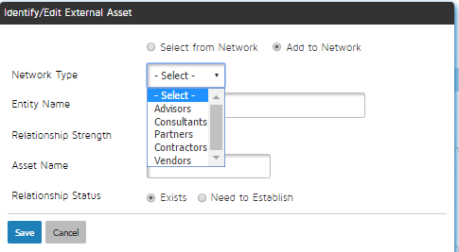

Figure : Add a new connection for Project Asset Need

In either of the 2 cases, the relationship may already exist or it may need to be established. If the same already exists, the user can click and proceed to add other items.

If the NOE relationship needs to be established, the screen shown in Figure 29: Initiate Relationship building if the relationship needs to be established afresh, is shown to the user. Using this, the user can specify the planned dates with regards to establishing the relationship.

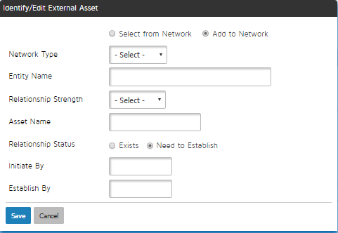

Figure : Initiate Relationship building if the relationship needs to be established afresh

### Knowledge Planning

To execute a project successfully, the project manager has to plan for the asset requirements. On clicking the  , the user is taken to the screen as shown in Figure 22: List of all Assets Required by the Project. The aggregated Knowledge items from all projects, based on the time when they are being executed, are used as BU Knowledge needs to derive the BU and Enterprise Level Knowledge Maps and Gaps.

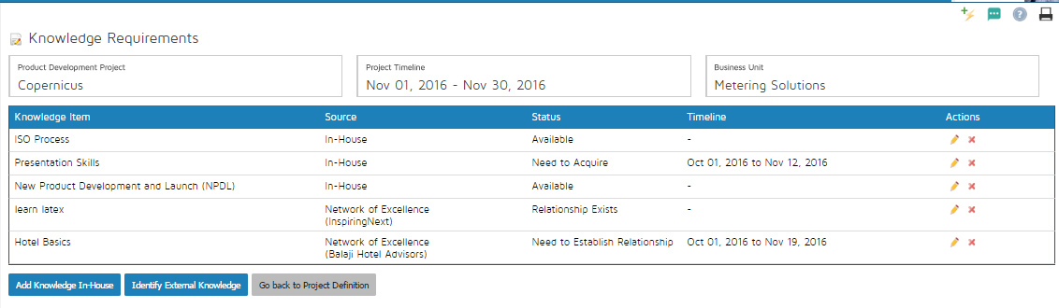

Figure : List of all Knowledge Items Required by the Project

#### In House Knowledge

An in-house Knowledge item is the one that is either already a part of the Knowledge framework, or is planned to be a part of the same.

On clicking the  button as shown in Figure 30: List of all Knowledge Items Required by the Project, the user is taken to the screen as shown in Figure 31: Add In-house Knowledge Items that already exist in the Application Knowledge Framework. The user can then either select the Knowledge from the Framework, or choose to add to the framework itself.

If the user chooses to select from the framework, the screen similar to Figure 31: Add In-house Knowledge Items that already exist in the Application Knowledge Framework is seen where the user selects the name of the Knowledge from the dropdown and selects the level and the quantity of the Knowledge items.

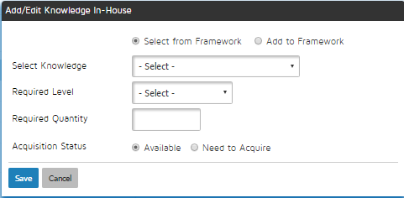

Figure : Add In-house Knowledge Items that already exist in the Application Knowledge Framework

If the user chooses to add to the framework, a screen shown in Figure 32: Add a new knowledge item to the project AND to the Application Knowledge Framework is seen. The user enters the name of the Knowledge, its category, level and quantity and the same gets added to the Framework.

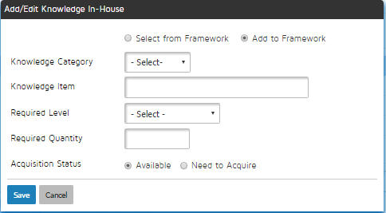

Figure : Add a new knowledge item to the project AND to the Application Knowledge Framework

In both the above cases, the Knowledge may already be available or it may need to be acquired. If the Knowledge is available, the user can just save and proceed further.

If the knowledge needs to be acquired, as shown in Figure 33: Plan for Knowledge acquisition if not available, the user needs to enter the start and end dates of acquisition.

The end date of acquisition needs to be on or before the end date of the project. The start date must be before the end date.

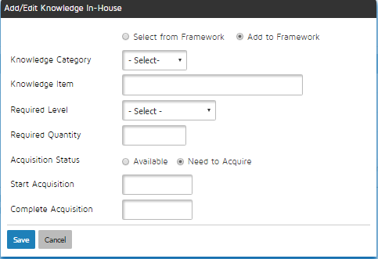

Figure : Plan for Knowledge acquisition if not available

#### Knowledge Sourced from NOE

An external knowledge item may be planned for when the asset required is neither a part of the framework, nor is planned to be in the foreseeable future. This may include, but not limited to, expensive royalty and licensing requirements that are impractical to develop in house.

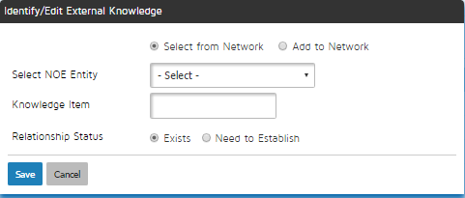

Figure : Identify an existing connection for Project Knowledge Needs

To add an external Asset, click the  on the screen shown in Figure 30: List of all Knowledge Items Required by the Project. This opens up the screen as shown in Figure 34: Identify an existing connection for Project Knowledge Needs.

If the NOE entity exists, you can select from the dropdown and enter the Knowledge name that you would like to use from the NOE. This is as shown in Figure 35: Add a new connection for Project Knowledge Needs

If the NOE entity needs to be added, The user may enter the network type, the NOE entity name, The relationship strength and the Knowledge name. This adds the NOE basic details to the Network of excellence Database.

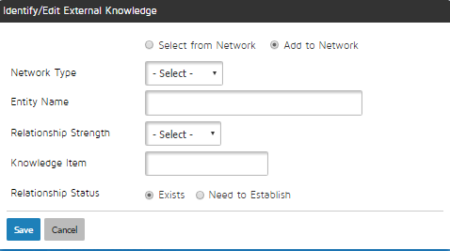

Figure : Add a new connection for Project Knowledge Needs

In either of the 2 cases, the relationship may already exist or it may need to be established. If the same already exists, the user can click and proceed to add other items.

If the NOE relationship needs to be established, the screen shown in Figure 36: Initiate Relationship building if the relationship needs to be established afresh, is shown to the user. Using this, the user can specify the planned dates with regards to establishing the relationship.

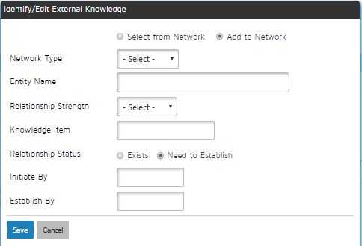

Figure : Initiate Relationship building if the relationship needs to be established afresh

### Technology Requirements

Technology requirements for a Product Development Project cover the scenario where a new technology has to be developed in order to successfully complete the Product Development.

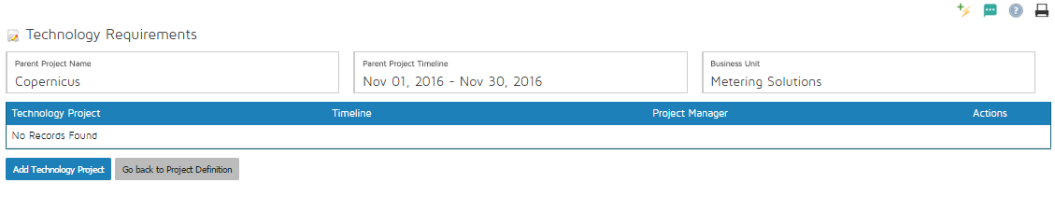

Figure : List of Technology Projects that need to be done before the Product's project can be completed

Clicking the  button on the screen shown in Figure 15: Project Page after Saving Basic Details, You come to the screen as shown in Figure 37: List of Technology Projects that need to be done before the Product's project can be completed. This lists all the technology projects that need to be completed before the product development project can be finished.

On clicking the  button on the screen shown in Figure 37: List of Technology Projects that need to be done before the Product's project can be completed, a screen as shown in Figure 38: Create a new linked Technology Project opens up. The user must enter

1. The name of the project
2. Project description
3. Priority of the project
4. The estimated project start and Project end date. The application does not allow the end date of the technology project to be later that the end date of the parent product devlopment project

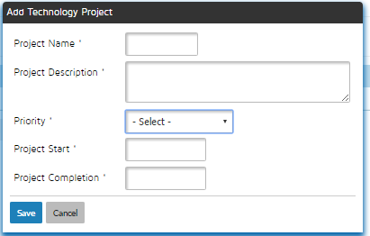

Figure : Create a new linked Technology Project

Saving these details leads to a creation of technology project with minimal details, which can be seen in the list of projects as shown in Figure 13: List of All Projects. The Parent project field of the Technology development project is set to the Product development project

Also, a high priority action item is created for the project manager of the Parent Product development project to fill out all the details for the newly created Technology Development Project.

The action items are viewable from the action item reports.

### Project Risk Management

On clicking the button on the screen shown in Figure 15: Project Page after Saving Basic Details, the user is taken to the project as shown in Figure 39: List of all project risks along with their RPN

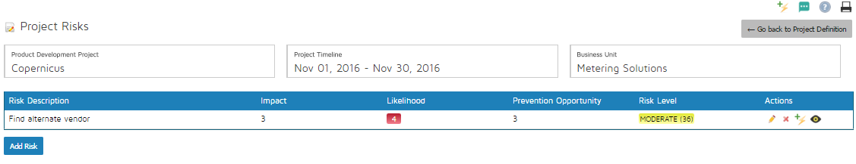

Figure : List of all project risks along with their RPN

The screen lists all identified prject risks, along with their RPN and Impact/Likelihood and Prevention Opportunity. Then same is colour coded for Easy visualisation.

On clicking the  button, the user is taken to the screen shown in Figure 40: Add a new risk to the Project.



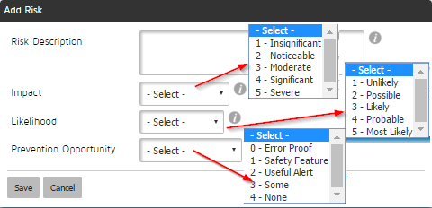

Figure : Add a new risk to the Project

The toolbar to the right of each risk () enables ( from left to right):

1.  icon enables editing the risk entered above
2.  icon enables deleting the risk entry
3.  icon enables entering mitigation/contingency actions, as shown in Figure 41: Add Mitigation or Contingency Actions
4.  icon enables viewing the actions entered against a specific risk. This is as shown in Figure 42: View all Action Items Linked to a Risk

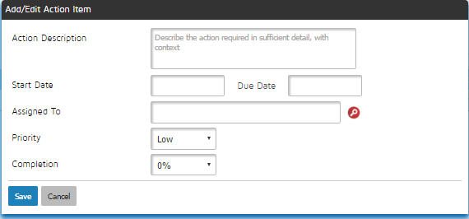

Figure : Add Mitigation or Contingency Actions

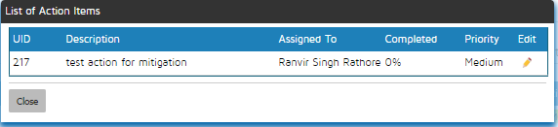

Figure : View all Action Items Linked to a Risk

### Project Tasks

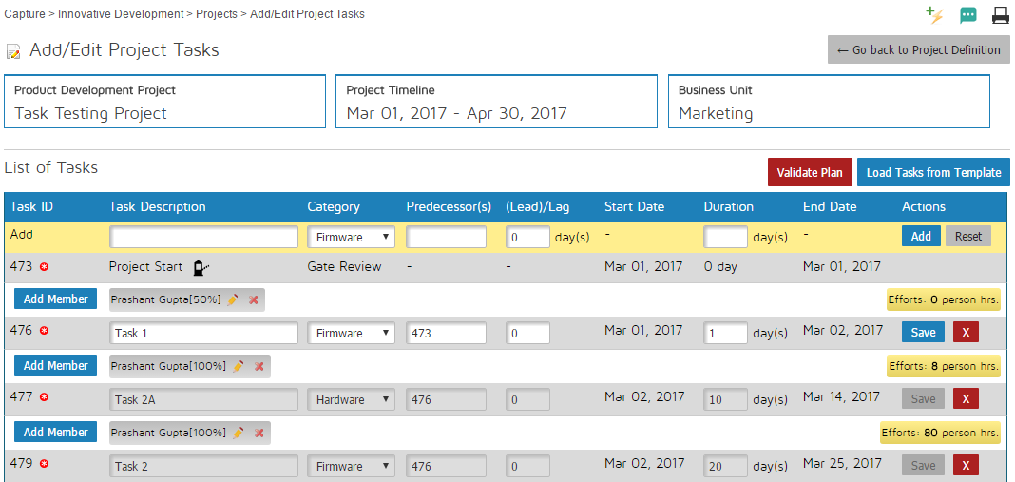

Figure : Add Project Tasks and Task Details

On clicking the  button on the page shown in Figure 14: Capture the Basic Project Details, the user sees the page shown in Figure 43: Add Project Tasks and Task Details. This page enables multiple features:

1. The project gates linked to the project category selected in the page shown in Figure 14: Capture the Basic Project Details are automatically populated.
2. The yellow bar at the top of the task table allows the user to add a new task by entereing the task description, selectng the task category, selecting the predecessors of the task that must be comma seperated, the lag/ lead in signed days, and the duration of the task. Please note that all the dates are automatically calculated and can not be manually entered.
3. Once a task is added, members can be added to the task by clicking the  button that brings up the page shown in Figure 44: Add resources to a Task. Here the project manager can select an employee and also specify the involvement of the member as a percentage of the total number of person hours available.
4. Once all the tasks have been added, the user can click on Validate Plan button to conduct various checks on the schedule, such as
   1. Check if all tasks have predecessors except the first task
   2. Check if all tasks have successors except the last task
   3. Check if the predecessor and successors do not have a circular relationship
   4. Check if there is at least 1 task that starts on the project start date
   5. Check if there is at least 1 task that ends on the project end date
   6. Task size warning – tasks larger than 3 days generate a warning
   7. Check if all tasks have resources assigned to them.
5. Validate plan also calculates the critical path and the tasks are marked by a if they do not have slack. Critical path is the longest sequence of activities in a project plan which must be completed on time for the project to complete on due date. An activity on the critical path cannot be started until its predecessor activity is complete; if it is delayed for a day, the entire project will be delayed for a day unless the activity following the delayed activity is completed a day earlier.
6. The effort in person hours is calculated for each task based on the number of resources, their percentage involvement, their grade level and the number of days.
7. The cost of each activity is calculated based on the effort and the rate specified in the grade of the selected resource.
8. Assigning a task to a resource also adds them to the project team, so that the talent maps can be reviewed again.
9. All the tasks added are converted to action items for the assigned resources, so that all the tracking machinery of an action item such as email notifications, escalations etc are available on the dashboard.

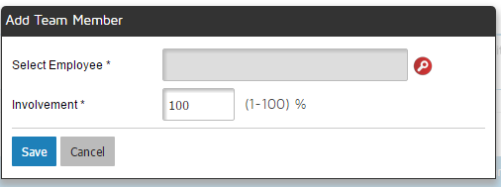

Figure : Add resources to a Task

### Publishing the project

Clicking on the  button on the screen on Figure 15: Project Page after Saving Basic Details, would publish the project and prevent further changes to the project data entry. This will also oenable gate reviews. All publish and unpublish actions (Figure 45: Publish the Project for Go-Live) are logged with the user name and the date and time of the action. Unpublishing will reenable editing and disable access to gate reviews.

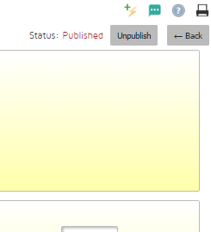

Figure : Publish the Project for Go-Live

### Project Execution- Gate Reviews

If the project is published, the user sees a  icon to the left of the project entry and a new  icon appears to the right of the project entry. These are visible in the screen capture in Figure 46: Access Gate Reviews.

The  icon is used during project execution to access gate review interface.



Figure : Access Gate Reviews

On clicking the  icon, the screen shown in Figure 47: Project Gate Review Dashboard; with Checkpoints and all previous Review Records, can be seen.

Here, the user sees the checklist of the next due gate in the top left half, the status of all the project gates on the top right half; and a running log of all gate reviews held in the past along with their outcomes in the bottom of the screen.

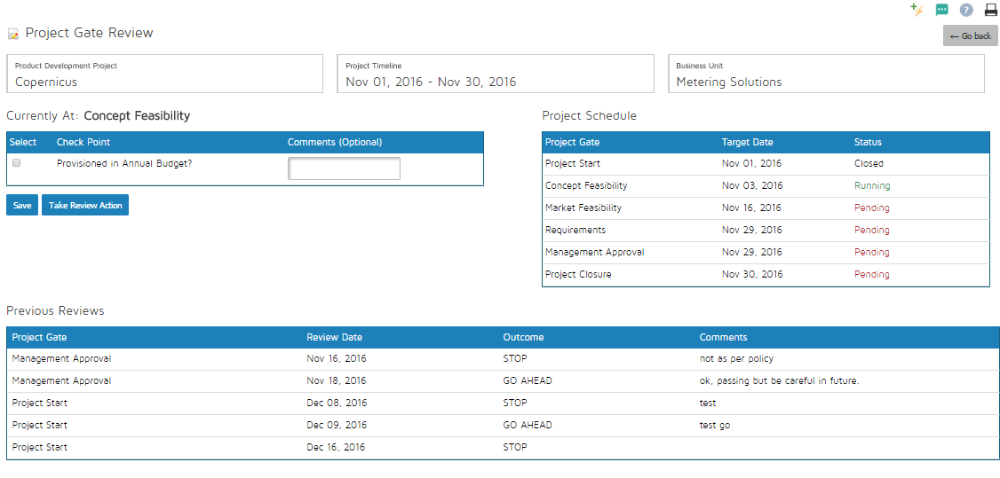

Figure : Project Gate Review Dashboard; with Checkpoints and all previous Review Records

While conducting a gate review, the user selects the checkbox next to each checkpoint in the checklist and enters comments. The user then clicks the  and the screen shown in Figure 48: Verdict of a Review is shown to the user.

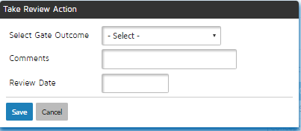

Figure : Verdict of a Review

The user can select one of the gate outcomes defined in the framework, enters the comments and review date and saves. These are then added as a part of the review history.

If the outcome selected is defined to be the one that passes the date, the checklist of the next due gate is now visible.



Figure : Project acquisition status

The page also allows the project manager to mark the status of all acquisition activities and mark them as acquired as done. This is shown as a green bar in the Roadmap.

### Project Execution- Timesheet entry

As the project team members perform their tasks, they need to fill up the timesheets. On navigating to the page shown in Figure 50: Enter Project Task timesheet for Planned Tasks, the user selects the activity type.

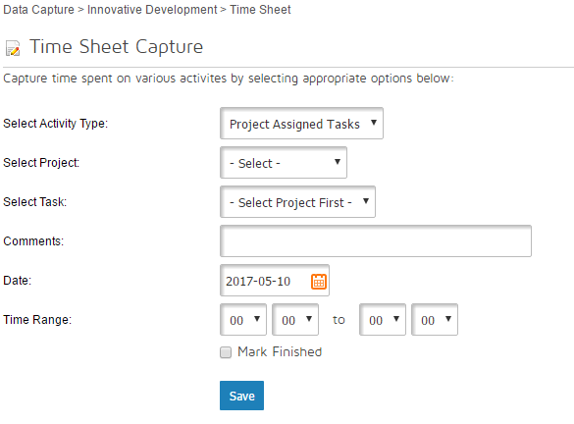

Figure : Enter Project Task timesheet for Planned Tasks

1. If the user selects , only projects that have the user as a team member are visible.
   1. The user then selects that task from the dropdown. This contains the tasks that are assigned to the user, but are neither marked as finished, not approved by the PM.
   2. The user then selects the date and the time range, and saves.
   3. If the task in question is finished, the user can click the  checkbox, and the task no longer appears in the dropdown.
2. If the user selects , the list of all published, but not closed projects appears in the dropdown. The user can then select the project and add the task description. This is as shown in Figure 51: Enter Project Timesheet for unplanned Tasks

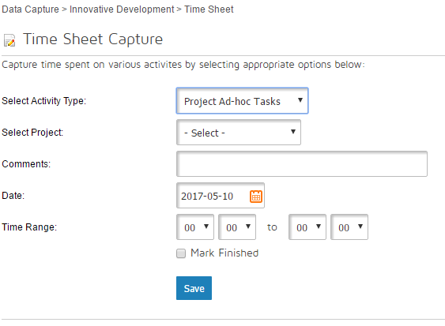

Figure : Enter Project Timesheet for unplanned Tasks

1. The user can select Action Items to enter timesheets against activities that have been assigned from sources other than projects, such as

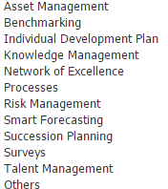

This is as shown in Figure 52: Enter Timesheet for tasks assigned other than Project Tasks.

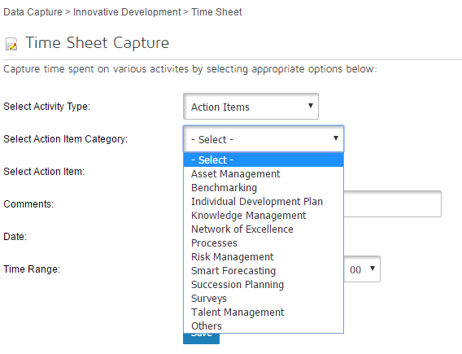

Figure : Enter Timesheet for tasks assigned other than Project Tasks

1. The user may also want to capture timesheets for unplanned activities, which is illustrated in Figure 53: Capture Timesheet for Unplanned Activities below.

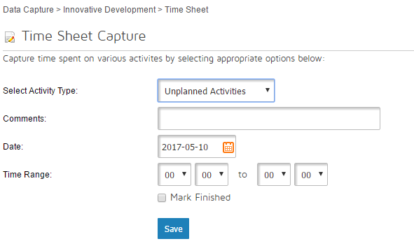

Figure : Capture Timesheet for Unplanned Activities

The user can choose to see their timesheet entries for any given date. There is an option to delete a wrong timesheet entry as well, provided the task is not already approved by the project manager. This is shown in Figure 54: See/Delete your Timesheet Entries

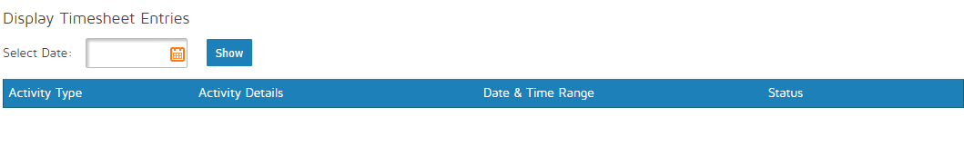

Figure : See/Delete your Timesheet Entries

### Project Execution- Project Task approval

The timesheet approval page shown in Figure 55:Approve your project timesheets and Task Completion page allows the project manager to view all tasks in the project along with their time sheet entries. The project manager sees all their projects that have been published.

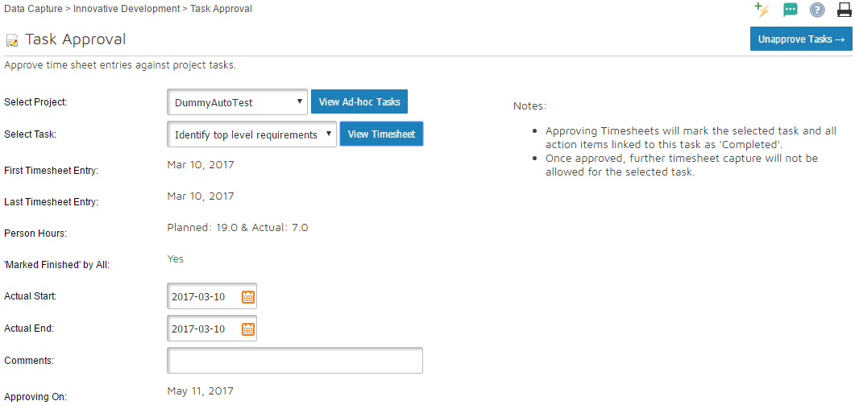

Figure :Approve your project timesheets and Task Completion

The project manager can approve the completion of the task based on the information on this page. Note that the project manager can approve any task irrespective of its timesheet entries.

Approval of a task removes it from all users’ timesheet dropdowns and marks the connected action items as done.

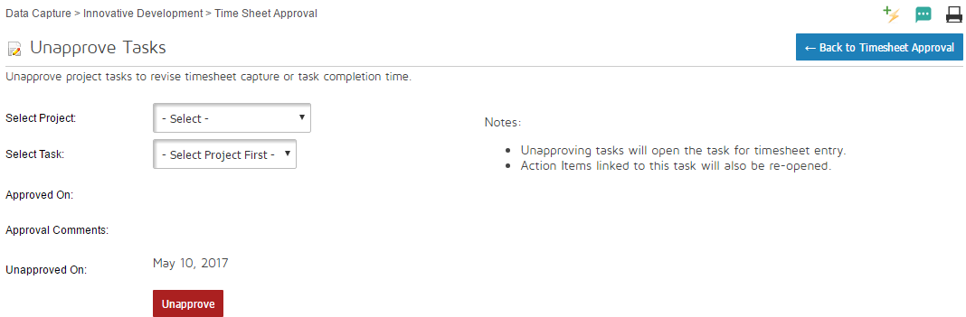

Figure : Un-approve a previously approved task

Should the project manager choose to change their mind with regards to the approval of tasks, they can undo the approval. This will make the task available for timesheet entry again. This is as shown in Figure 56: Un-approve a previously approved task.

## Reports

### Projects Report

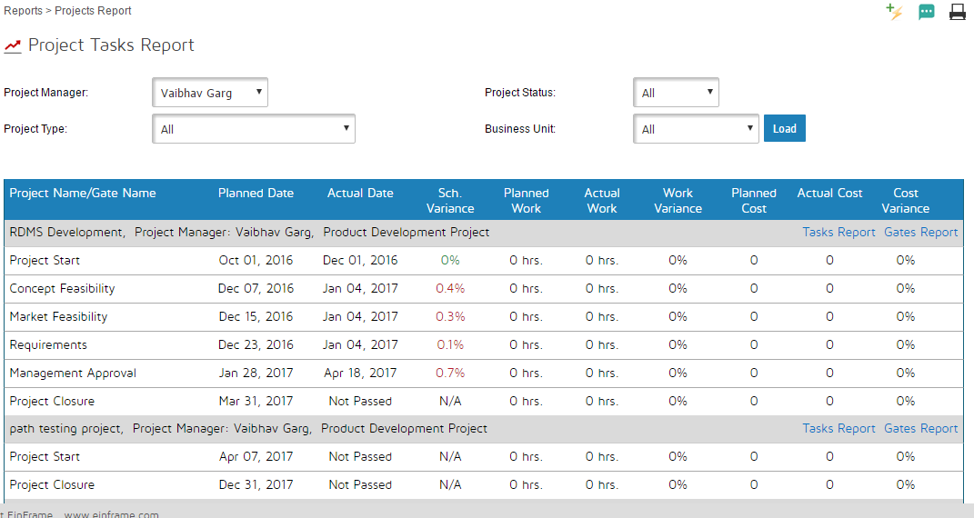

Figure : Project Report

This is an organisation level report with the following information. This is as illustrated in Figure 57: Project Report.

|  |  |  |  |  |  |  |  |  |  |  |  |  |  |  |
| --- | --- | --- | --- | --- | --- | --- | --- | --- | --- | --- | --- | --- | --- | --- |
| **Project Manager** | | | | Project Manager Dropdown; including all | | | | | | | | | | |
| **Project Type** | | | | All/Product/Technology Dropdown | | | | | | | | | | |
| **BU Dropdown** | | | | All/Enterprise Level/BU Names Dropdown | | | | | | | | | | |
| **Status Dropdown** | | | | Running/Completed | | | | | | | | | | |
| Project Name | Project Type | Project Manager | Gates | | Planned Date | Actual Date | Schedule Variance | Planned work | Actual Work | Work Variance | Planned Manpower Cost | Actual Manpower Cost | Cost Variance |
| Project A | Product Development | Mr. ABC | Start | |  |  |  |  |  |  |  |  |  |
|  |  |  | Gate 1 | |  |  |  |  |  |  |  |  |  |
|  |  |  | Gate 2 | |  |  |  |  |  |  |  |  |  |
|  |  |  | Finish | |  |  |  |  |  |  |  |  |  |
| Project B | Technology Development | Mr. XYZ | Start | |  |  |  |  |  |  |  |  |  |
|  |  |  | Gate 1 | |  |  |  |  |  |  |  |  |  |
|  |  |  | Finish | |  |  |  |  |  |  |  |  |  |

### Project Gates Report

On navigating to this report, as shown in Figure 58: Project Gates Report with dates and results, the status of all the gates along with the captured comments and the verdict are shown. This facilitates gate status tracking

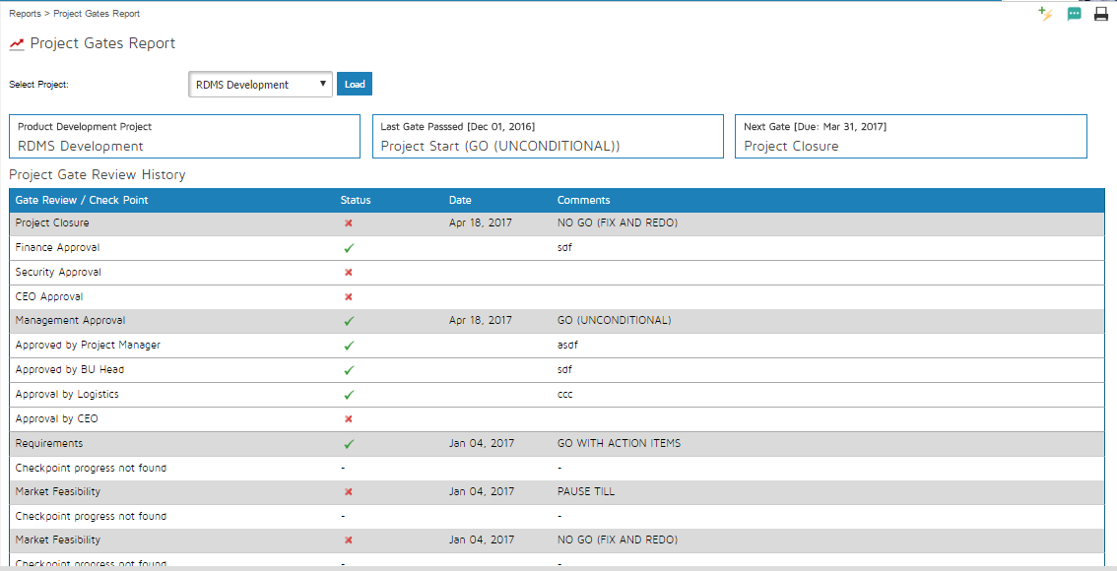

Figure : Project Gates Report with dates and results

### Project Tasks Report

All the project tasks along with their metrics are shown in this report. This is as shown in Figure 59: Project task level tracking report with critical path highlighting.

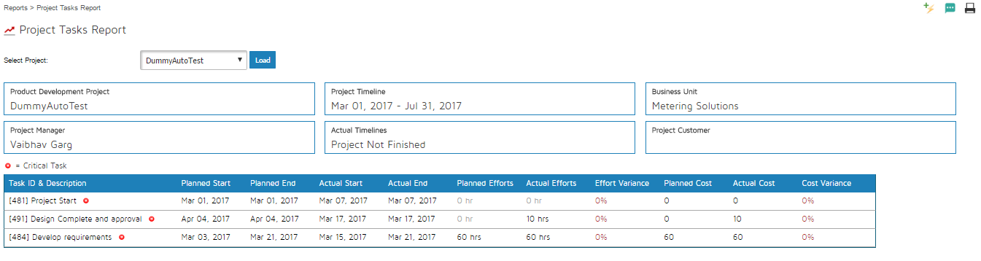

Figure : Project task level tracking report with critical path highlighting

### EVMS Chart Report

For a given project, the planned value, Earned value and the Actual cost are shown in this chart. This gives deep insight on the project performance.

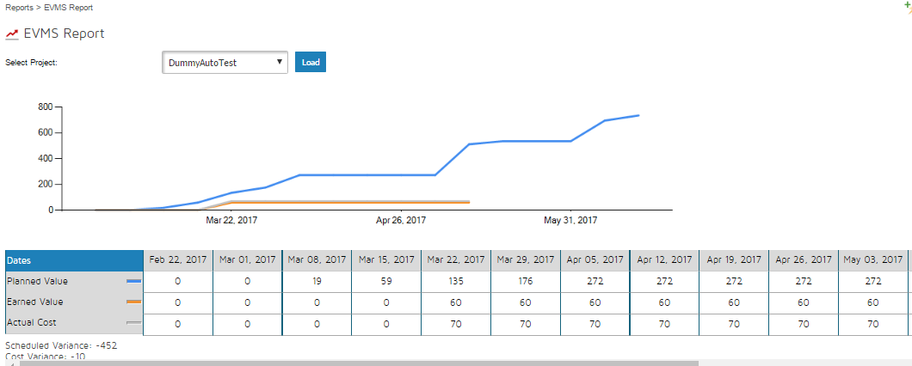

Figure : PV, EV and AC EVMS chart

### Bull’s Eye Chart Report

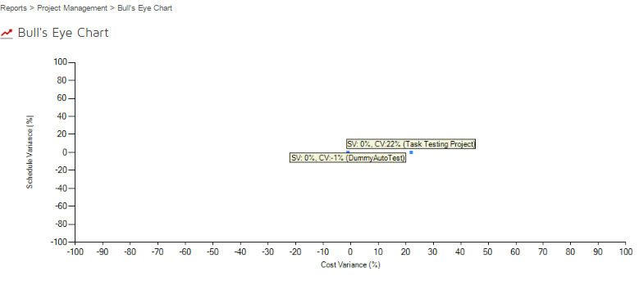

Figure : Organisation Level Bull's Eye Report for SV and CV

### Timesheet Download

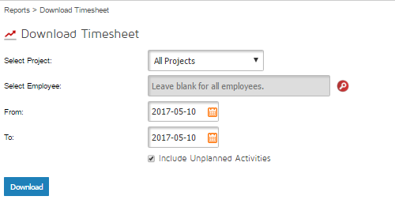

Figure : Download Timesheet Data

### Resource Loading

Navigation:

Reports>>Resource Loading

The resource loading report is intended to show the %age of time that an employee is allocated in projects.

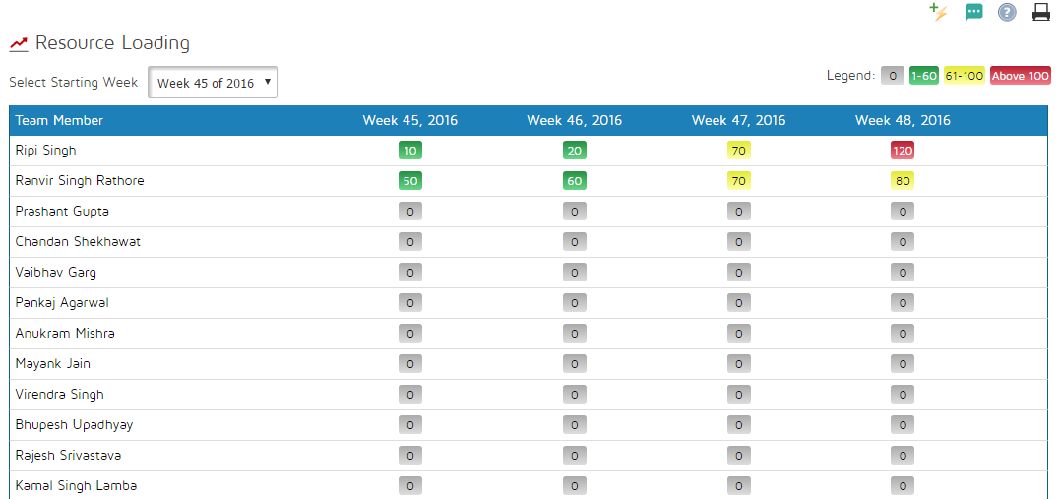

Figure : Resource Loading Report

The user can select any starting week from the dropdown on the top and view an aggregate of percentage loading. The loading is colour coded so that any hot-spots are easily spotted.